**HashiCorp Cloud Platform Setup**

Follow the steps below to configure and use HCP for Terraform deployment from cloud:

1. Go to the following link and sign up with your email address to an HCP account: <https://portal.cloud.hashicorp.com/>

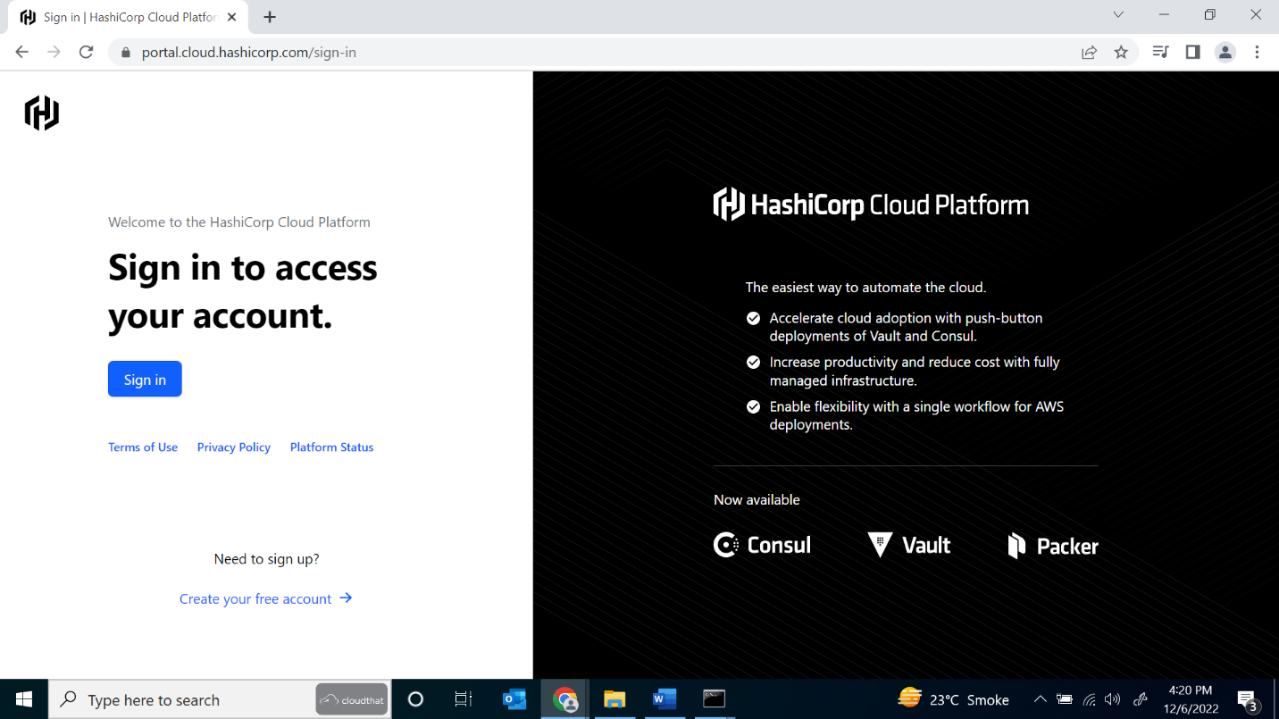

1. Enter the name of your organization and the country to create an organization in your HCP account:

1. Skip adding the payment method and you would be redirected to your organization:

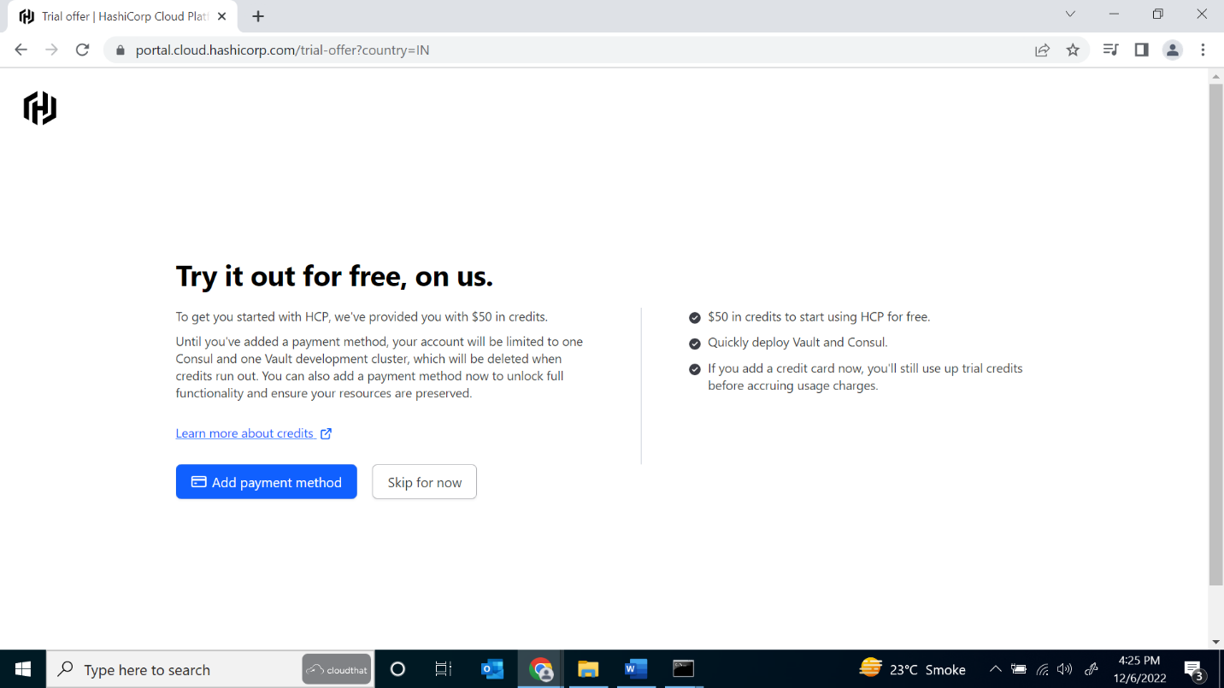

1. From the left blade click on Terraform and then Continue to Terraform Cloud:

1. You will be redirected to <https://app.terraform.io/> where you need to create workspace. Click on New Workspace on the top right:

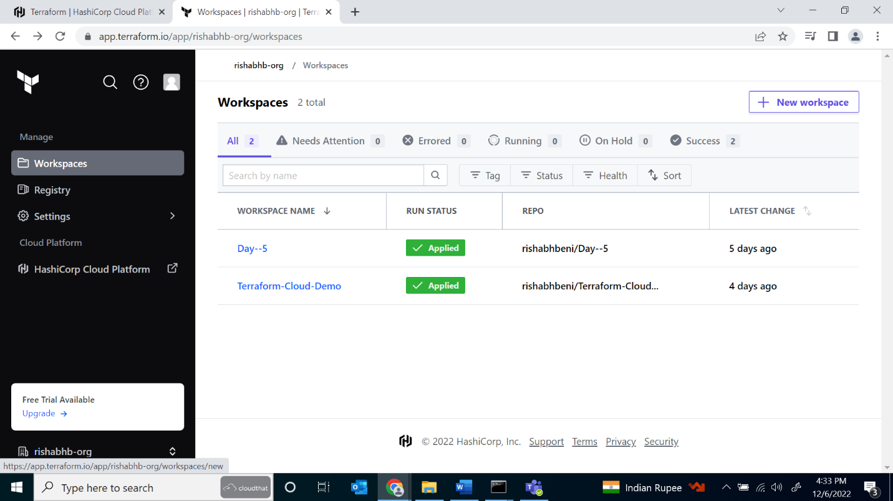

1. Then in Choose Type select Version Control Workflow:

1. In connect to VCS, select GitHub as your version provider. Then you need to authenticate with GitHub so that it will display your GitHub repos:

1. Choose from an existing repo that has Terraform files which you need to run in Terraform Cloud. If you don’t have an existing repo you can Fork the example repo from HashiCorp below:

1. After selecting the repo just confirm the name of your workspace and click create workspace:

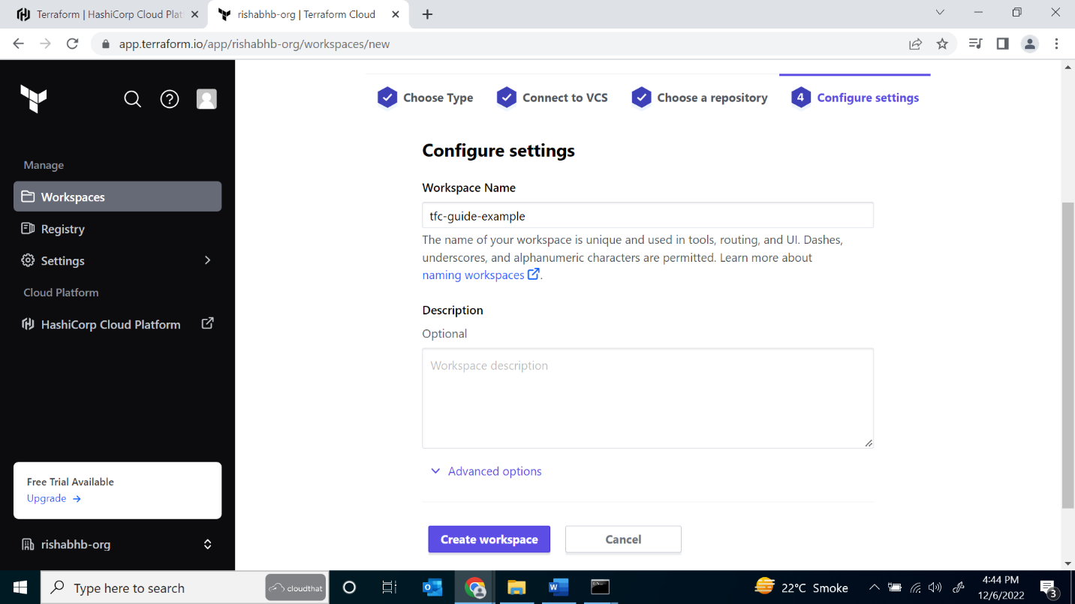

1. Once your workspace is created you can start a new plan to plan the configuration in the Terraform files:

1. You can enter the reason and select plan and apply which will start to run your configuration in Terraform Cloud:

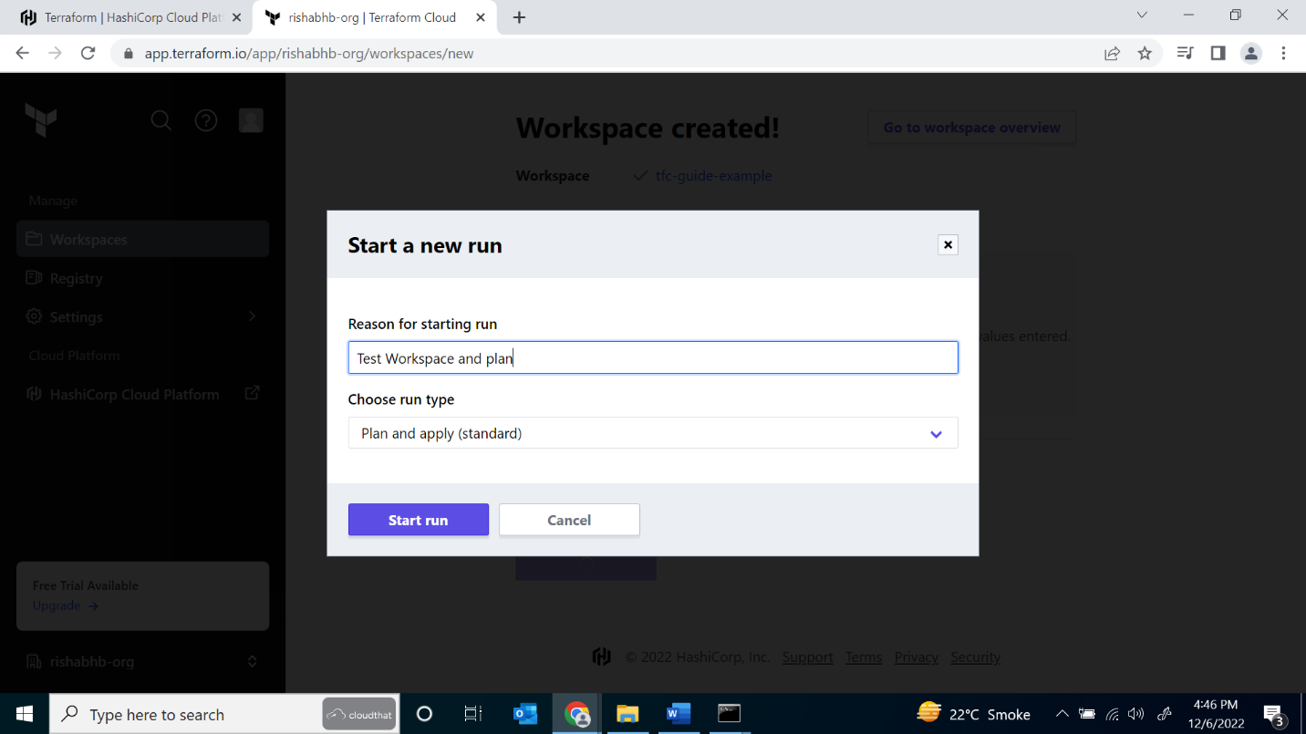

1. Once the plan and apply finishes you it will deploy your resources to your Azure portal using the Service Principal you have configured in your Terraform files:

